“So What Are We to do in This Election?”

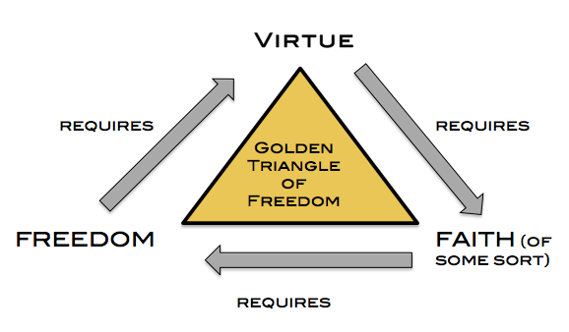
“The only foundation of a free Constitution is pure virtue.” – John Adams
“Only a virtuous people are capable of freedom.” – Ben Franklin
“We have no government armed with power capable of contending with human passions unbridled by morality and religion. Avarice, ambition, revenge, or gallantry, would break the strongest cords of our Constitution as a whale goes through a net. Our Constitution was made only for a moral and religious people. It is wholly inadequate to the government of any other.” – John Adams
I. Our responsibilities on November 8
- Vote no matter what
- Vote for President
Consider two things:
- Party platform

- Judicial and Cabinet appointments

- Rest assured in the sovereignty of God
Psalm 103:19, “The Lord has established his throne in the heavens, and his kingdom rules over all.”
Job 12:10, “In His hand is the life of every living thing and the breath of all mankind.”
Job 12:23, “He makes nations great, and he destroys them; he enlarges nations and leads them away.”
Daniel 2:21, “He changes times and seasons; he removes kings and sets up kings; he gives wisdom to the wise and knowledge to those who have understanding.”
Proverbs 21:1, “The king’s heart is a stream of water in the hand of the Lord; He turns it wherever He will.”
- Our responsibilities on November 9 and beyond
- Love the Lord completely (Matthew 12:30)
Matthew 12:30. “And you shall love the Lord your God with all your heart and with all your soul and with all your mind and with all your strength.”
- Love your neighbor as yourself (Matthew 12:31)
Matthew 12:31, “The second is this: ‘You shall love your neighbor as yourself.’ There is no other commandment greater than these.”
- Pray for the President and other government leaders (I Tim 2:1-4)
I Timothy 2:1-4, “First of all, then, I urge that supplications, prayers, intercessions, and thanksgivings be made for all people, ² for kings and all who are in high positions, that we may lead a peaceful and quiet life, godly and dignified in every way. ³ This is good, and it is pleasing in the sight of God our Savior, ⁴ who desires all people to be saved and to come to the knowledge of the truth.”

- Live a godly life (I Timothy 2:2-4)

- Pray for spiritual revival (Psalm 85:6-7)

Psalm 85:6-7, “Will you not revive us again, that your people may rejoice in you? Show us your steadfast love, O Lord, and grant us your salvation.”

