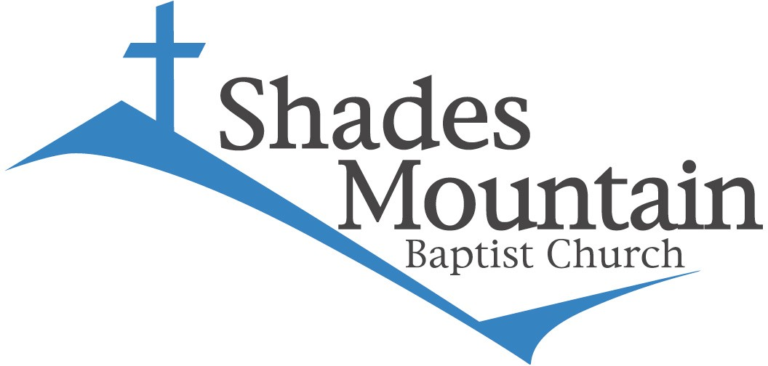**SHADES MOUNTAIN MISSION PROJECT VOLUNTEER APPLICATION**

### Please complete this form in its entirety in black ink. Sign the form where indicated.

***Note: It is important that you use your name as it appears on your passport and/or other legal document.***

LAST NAME FIRST NAME MIDDLE

DATE OF BIRTH (MONTH/DAY/YEAR) GENDER: Male Female

MAILING ADDRESS

CITY STATE ZIPCODE

HOME PHONE MOBILE PHONE

E-MAIL ADDRESS

MARITAL STATUS: Single Married IF MARRIED, NAME OF SPOUSE

OCCUPATION EMPLOYER

PASSPORT NUMBER PASSPORT EXPIRATION DATE

HAVE YOU EVER BEEN ON A MISSION PROJECT? IF SO WHERE

______________________________________________________________________________________________________________

HAVE YOU EVER BEEN ON A MISSION PROJECT WITH SHADES MOUNTAIN BAPTIST? _____ YES _____ NO

**I understand that my deposit is non-refundable and that I will be responsible for expenses related to airline tickets purchased in my name upon cancellation.** The training meetings for this mission project are critical for the spiritual unity and physical preparation of the entire team. I commit to faithfully attend all meetings at the scheduled times to the best of my ability.

Signature Date Signed / /

## HEALTH HISTORY

NAME OF YOUR PERSONAL PHYSICIAN PHONE

YOUR BLOOD TYPE

PLEASE LIST ANY MEDICAL PROBLEMS

DO YOU HAVE ANY ALLERGIES (i.e. food, drugs, insect bites, stings, etc.). If so, please list:

PREVIOUS OPERATIONS OR SERIOUS ILLNESSES (Also list dates)

CURRENT MEDICATIONS (List all)

SPECIAL DIET (Describe)

NAME OF YOUR DENTIST PHONE

HAVE YOU HAD? PLEASE CIRCLE

|  |  |  |
| --- | --- | --- |
| 1) HEPATITIS A VACCINE? | YES | NO |
| 2) MEASLES, MUMPS, AND RUBELLA (MMR) VACCINE? | YES | NO |
| 3) TETANUS, DIPHTHERIA, AND PERTUSSIS (TDAP) VACCINE? | YES | NO |
| 4) TYPHOID VACCINE? | YES | NO |
| 5) TETANUS BOOSTER IN LAST FIVE TO TEN YEARS? | YES | NO If yes, date: |
| 6) FULL HEPATITUS B IMMUNIZATION SERIES? | YES | NO |

## HEALTH INSURANCE

NAME OF INSURANCE COMPANY

ADDRESS

PHONE NUMBER OF INSURANCE COMPANY

THIS POLICY IS ISSUED IN THE NAME OF

ADDRESS

IF GROUP POLICY, PLEASE LIST EMPLOYER

EMPLOYER PHONE NUMBER

ANY OTHER PERTINENT HEALTH INFORMATION (Please describe)

## EMERGENCY CONTACTS (please provide 2 contacts)

**NAME** RELATIONSHIP TO YOU

ADDRESS

DAY PHONE NIGHT PHONE

**NAME** RELATIONSHIP TO YOU

ADDRESS

DAY PHONE NIGHT PHONE

## MISCELLANEOUS

WHAT T-SHIRT SIZE DO YOU PREFER?

YOUR HOME CHURCH (IF NOT SHADES MOUNTAIN) CHURCH ADDRESS PHONE

CHURCH RECOMMENDATION (IF OTHER THAN SHADES MOUNTAIN):

wholeheartedly recommends the applicant to Shades Mountain Baptist Church as sound in his/her faith and spiritually equipped to serve on this volunteer project.

Signature of Pastor Date Signed / /

## CHECKLIST:

**Please attach the following to your application:**

# Copy of your passport (photo identification page)

* Copy of your medical insurance card
* Copy of your secondary insurance card (if applicable)

***SMBC MISSION PROJECT VOLUNTEER RELEASE AND COVENANT NOT TO SUE***

Name: Parent/Legal Guardian Name

Address: City: State Zip

Telephone: (Mobile) (Work) (Home)

In consideration for travel to and participation in one or more mission projects sponsored in whole or in part by Shades Mountain Baptist Church and for services performed during such mission project by Shades Mountain Baptist Church, its agents, employees, trustees, officers, directors, administrators, team leaders, team coordinators, team members, volunteers, sponsors, successors and assigns and all others acting in any capacity on their behalf to conduct the mission project (collectively “SMBC”), **I HEREBY AGREE TO RELEASE, DISCHARGE, INDEMNIFY AND HOLD HARMLESS SMBC ON BEHALF OF MYSELF, MY SPOUSE, MY CHILDREN, MY PARENTS, MY HEIRS, ASSIGNS, PERSONAL REPRESENTATIVES AND ESTATE AS FOLLOWS:**

1. I acknowledge that engaging in a mission project entails both known and unknown risks that might result in illness, severe physical and emotional injury, death, damage or loss of property. Such risks include, but are not limited to: accidents in the course of travel; risk of injury or illness commonly associated with construction, recreation or other mission service activities (including the risk of negligent acts or omissions); and risks associated with living and working in regions with underdeveloped security, buildings, road, sanitation, food, water, and health care services and facilities. I understand that such risks are inherent to and cannot be eliminated from mission service.
2. I understand that the mission project may involve travel to countries and regions where there is a risk of political instability, criminal or terrorist activity.
3. I acknowledge that I have been provided an opportunity to inquire about the known health and safety hazards, conditions, and environment existing in the country in which the mission project will be conducted and assume all risks of participation.
4. I acknowledge that I am fit and able to take part in the sponsored activities.
5. My participation in the SMBC mission project is purely voluntary, and I expressly agree to accept and assume all risks of participation. **I specifically agree to accept and assume the risk that SMBC may commit negligent acts or omissions during the mission project. I also agree to accept and assume the risk that any injury or illness I may suffer during the mission project may be made worse by negligent treatment or rescue efforts by SMBC or third parties.**
6. I hereby voluntarily, irrevocably, and unconditionally release, forever discharge, and agree to indemnify and hold harmless SMBC from any and all claims, demands, or causes of action, which in any way arise from or are related to my participation in an SMBC mission project, including all claims of negligence should I be injured, suffer loss, or become ill in any way as a consequence of my participation.
7. Neither I nor anyone on my behalf will institute legal action against SMBC for any injury to person or property, including injury from negligent acts or omissions, related to my participation in the mission project.
8. I represent that I am at least 18 years of age and otherwise competent to sign this Release and Covenant Not to Sue. This Release shall be binding to the fullest extent permitted by law. If any part of this release is deemed to be unenforceable, the remaining terms shall be enforceable as a contract between parties. This release shall be binding upon my assignees, subrogors, heirs, next of kin, executors and personal representative.
9. Unless indicated to the contrary, I acknowledge that Shades Mountain Baptist Church may, in its sole discretion, use my photograph and/or comments in various forms of media, e.g. videos, publications, etc.

Do ***not*** use my photograph or image.

#### By signing this document, I acknowledge that I have waived my right to maintain a lawsuit against SMBC, including that SMBC has committed negligent acts or omissions. I had sufficient opportunity to read this entire document. I have read and understood it, and I agree to be bound by its terms.

**Signature of Participant**

**Print Name Date:**

**PARENT OR GUARDIAN’S ADDITIONAL RELEASE AND INDEMNIFICATION**

(Must be completed by the parent or legal guardian for participants under the age of 18).

I hereby acknowledge and represent that I am legal custodian of (insert minor’s name) (“Minor”) and have the authority to execute this release on behalf of Minor. In consideration of being permitted by Shades Mountain Baptist Church to participate in one or more mission projects, I have read and understand the foregoing “Volunteer Release and Covenant Not to Sue and agree that its terms and provisions are incorporated herein and govern this Parent or Guardian’s Additional Release and Indemnification.

In regards to BOTH (1) Minor’s personal rights and (2) the personal rights of Minor’s parents or guardian, I agree to accept and assume all of the risks to Minor arising from or related to Minor’s participating in the mission project, including the **risk that SMBC may commit negligent acts or omission, and the risk that any injury or illness Minor experiences may be made worse by negligent treatment or rescue efforts by SMBC or third parties.**

**I hereby voluntarily release, forever discharge, and agree to indemnify and hold harmless SMBC** from any and all claims, demands, or causes of action, which in any way arise from or relate to Minor’s participation in SMBC mission project, **including all claims alleging negligence, and including negligence concerning treatment or rescue efforts, if Minor is injured in any way during the SMBC mission project.** This release also includes any liability or cost sustained as a result of the negligent, willful or intentional acts of the Minor.

Should Minor need medical treatment or attention during the mission project, I authorize and consent to treatment of Minor in the manner set out below in the Consent to Treatment section. Additionally, I authorize any hospital that provided treatment to minor to surrender physical custody of Minor to SMBC upon completion of treatment.

I acknowledge and agree I am responsible for all transportation costs should it be necessary for Minor to return home due to medical reasons, disciplinary action or otherwise.

#### Signature of Parent/Legal Guardian

**Print Name Date:**

**CONSENT TO TREATMENT**

I hereby give permission to medical personnel selected by the SMBC team leader or his/her designee (hereafter the “Authorized Agent”) to order X- rays, routine tests, and treatment for me. In the event of an emergency and my primary contact cannot be reached, I hereby give permission to the physician selected by Authorized Agent to secure proper treatment, hospitalize, order injections, anesthesia, surgery, or other necessary treatments for me. I further authorize the release of medical information to appropriate medical personnel and/or health coverage insurance companies. In addition, I understand that the Volunteer Release and Covenant Not to Sue releases any claim related to medical treatment received during the mission project. I understand that if I do not have medical insurance, I will be responsible for any medical expenses in the event of sickness or injury.

These authorizations remain in effect through the mission project unless revoked in writing and delivered to Shades Mountain Baptist Church.

#### Signature of Parent/Legal Guardian

**Print Name**

**CONSENT TO TRAVEL**

**Date:**

The above-name Parent or Legal Guardian of Minor has entrusted the Minor into the care of Shades Mountain Baptist Church and its agents as duly authorized representatives of Shades Mountain Baptist Church, while Minor participates in the SMBC mission project. The Parent or Legal Guardian hereby authorizes the Minor to travel with SMBC.

#### Signature of Parent/Legal Guardian

**Print Name Date:**

STATE OF ALABAMA

COUNTY OF

I, the undersigned, a Notary Public in and for said County in said State, hereby certify that on this date that who is known to me, acknowledged before me that, being informed of the contents of said instrument he/she voluntarily executed the same. Given under my hand and seal of office this day of 20 .

Notary Public Signature: My Commission Expires: